**Power Query Interview Questions**

Q) What is Power Query?

A) Power Query is an ETL Software in Power BI. Power Query is one of the Software in Power BI Desktop which is used for performing ETL Activities or Data Preparation Activities in Power BI.

Q) Why do we need Power Query? (OR) What we will do with Power Query Software?

A) Power Query is used to Move the Data that is required for Analysis from Data Sources to Power Pivot. Using Power Query we can connect to almost any Kind of Data Source(Excel, Oracle, SQL Server etc.) to Extract the Data that is Required for Analysis, we can Transform or Prepare the Data as per the Reporting Needs and finally Loads the Data into Power Pivot. In Power Query all these ETL work will be done with just Point and Click with the help of GUI Options.

Q) Which language is used in Power Query?

A) M (Mash up) is the Language used in Power Query behind the GUI Options to perform the ETL Activities.

Q) What is the data destination for Power Queries / Power Query?

A) All the Transformed Queries or Tables in Power Query will be loaded into Power Pivot. Power Pivot is the Destination for Power Query.

Q) How to Connect to Data Sources in Power Query?

A) Using New Source or Recent Sources you can connects to Data Sources in Power Query.

Q) What is Recent Sources? What it Contain?

A) Recent Sources is the place where Power Query will Store the Data Sources Connection information. Recent Sources will contain all the Data Sources Connection information to which we connected in Recent Times.

Q) Name types of Connectivity Modes in Power BI?

A) Below are the Connectivity Modes in Power BI

1. Import
2. Direct Query
3. Connect Live / Live

Q) Briefly explain about Power Query User Interface (UI)?

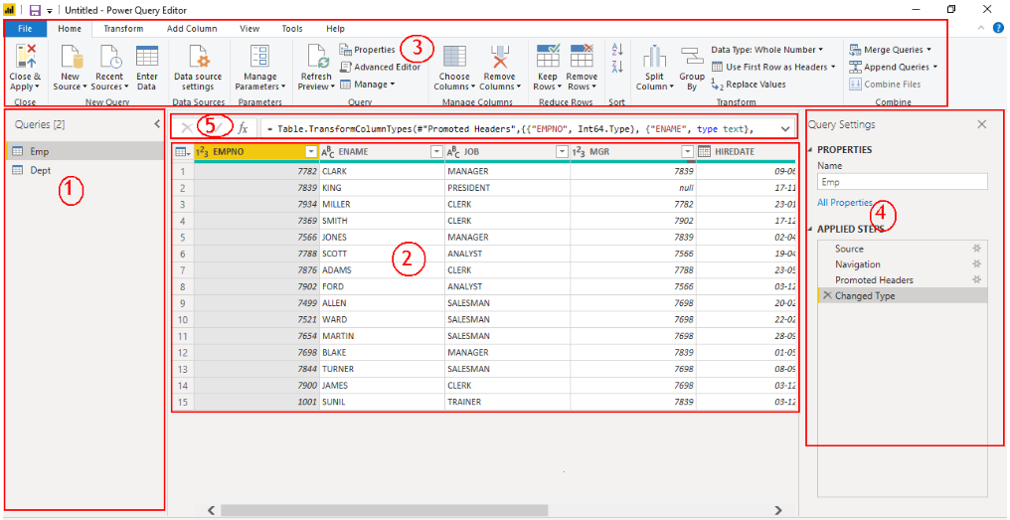

A) Power Query Editor User Interface Contains 5 Major Sections

1. **Queries Pane**

In Queries Pane we will see list of Tables we brought into Power Query. In Power Query Terminology Tables are called as Queries.

1. **Data Pane / Results Pane**

If we select a Table in Queries Pane, the selected table Data Can see in Data Pane. Also when you perform any Transformations on the Data, the transformed Results will be seen in Data Pane.

1. **Power Query Ribbon**

Power Query Ribbon will contain Multiple Tabs and each Tab will contain 100’s of GUI Options to Perform ETL Activities.

1. **Query Settings Pane**

Query Settings Pane Contains a Major Section Called Applied Steps. Applied Steps Contains all the ETL Activities we performed in Sequential Order for a Selected Table in Queries Pane.

1. **Formula Bar**

Formula Bar will Show M Language Code for a Selected ETL Step in Applied Steps Section.

Q) What are some common Power Query Transforms you performed?

A) Removing the unwanted Columns, Removing Unwanted Rows using Filters, Adding Conditional Columns, Merging the Columns, Splitting the Column, Joining the Tables using Merge Queries, Union the Tables using the Append Queries etc.

Q) How to Load Data into Power Pivot from Power Query?

A) Using Close & Apply GUI Option we can load the Data into Power Pivot.

Q) Can SQL and Power Query/Query Editor be used together?

A) Yes. We Can Write SQL Select Statements while Connecting to Data Source in Advanced Options and Once after Bring the Data using Select Statement into Power Query you can perform additional Transformations on the Data in Query Editor using the GUI Options. Hence we can use SQL and Power Query/Query Editor together.

Q) Where we can see the M Language Code of Each ETL Step we performed in Power Query?

A) Formula Bar is the Place Where we Can See ETL Code for each Step we Performed in Power Query. By Default Formula Bar will not Show in Power Query Editor User Interface, We need go to View Tab and Select the Formula Bar Check Box to see the Formula Bar in Power Query Editor User Interface.

Q) What is Advanced Editor in Power Query?

A) Advanced Editor is the Place where we can see Complete M Language Code for a Selected Table in Power Query.

Q) Can we Create Table in Power Query? If Yes How can we create?

A) Yes. Using Enter Data GUI Option we Can Create a Table in Power Query.

Q) How Can You Change the Data Source Connection information in Power Query?

A) Using **Data Source Settings** we can Change the Data Source Connection Information.

Q) How to Join the Tables in Power Query?

A) Using **Merge Queries** we will join the Tables in Power Query.

Q) What are the Prerequisites for Joining the Tables in Power Query? And what are Join Types / Join Kinds we have in Power Query?

A) The Prerequisites to Join Tables in Power Query is we need a Common Column in the Tables.

Below are the Join Types / Join Kinds available in Power Query

1. Left Outer
2. Right Outer
3. Full Outer
4. Inner
5. Left Anti
6. Right Anti

Q) How to join 3 Tables in Power Query?

A) First Join the Two Tables and the Result Join with Third Table.

Q) How to Union the Tables in Power Query?

A) Using Append Queries we Can Union the Tables in Power Query. When You Append the Queries default you will get Union ALL Result.

Q) How to Get Union Result in Power Query?

A) By Default when you append the Queries in Power Query will give Union All Result. To get Union result Once After Appending, Remove Duplicates at Table Level.

Q) You need to Import 150 CSV files to Power BI Desktop into One Table. All Files have the Same Structure. What do you do?

A) By Taking Folder as Source and Combine Files Option in Power Query we will append all 150 CSV files Data into One Table in Single Go.

Q) What is Pivot and UnPivot in Power Query?

A) Power Query in Power BI provides very effective functionality to pivot and unpivot columns. For the pivot functionality you turn rows to columns and for the unpivot functionality the inverse is true where columns are transformed into rows.

Q) Difference between Copy, Duplicate and Reference in Power Query?

A) Let’s see difference between Copy, Duplicate and Reference

When you press COPY then you can paste this query many times using PASTE option. As result you receive the same query with same connection and transformations. No connection to initial query.

When you press DUPLICATE you can have only 1 copy of query at one time. To repeat this action you need to press DUPLICATE one more time. As result you receive the same query with same connection and transformations. No connection to initial query.

If you press REFERENCE then it uses previous query as reference and apply all new steps based on reference query. Once you change initial query then it will automatically apply to dependent query.

Q) What is **Query Dependencies** Option in Power Query?

A) It is a Table View or Graphical View of all your tables/queries, showing the linkages between the tables/queries.

Q) What is Enable Load and Include in Report Refresh Query option?

A) Enable Load will help us to stop loading the unwanted tables into Power Pivot. By default all queries are enabled to Load into the Power Pivot model. Simply uncheck enable load option for queries that are not required in the Power Pivot Model.

Include in Report Refresh option will help us to stop refreshing the Static Dimension Tables when you refresh the Data Model. By Default all the Tables will refresh when you refresh the Data Model / Dataset. For Static Tables / Static Dimension Table Simply uncheck this Include in Report Refresh option.

Q) Can we Aggregate the Data in Power Query, if yes, How to Aggregate the Data in Power Query?

A) Yes we can aggregate the Data in Power Query using “**Group By”** GUI Option.

Q) What is **Columns from Examples** Option in Power Query? How it will help us?

A) “Column from Examples” Option will help us to create a New Conditional Column in the table by using “All Columns” or “Selected Columns” as source in the Table.

Q) When we will use **Custom Column** Option?

A) Custom Column Option will help us to Derive New Conditional Columns by writing our Own M Language Code.

Q) What is user-defined or custom function in Power Query?

A) In Power Query we have 100's of inbuilt functions available we still might need to create our own custom function to tackle repetitive tasks. Instead of writing the same code over and over again, create a user defined or custom function and save the time by using it.

Q) What is Invoke Custom Function Option? When we will use it?

A) Invoke Custom Function is used for calling the Custom Functions created by Developers.

What is Query Folding in Power Query? (OR) What is Query Collapsing in Power Query?

A) Query Folding is a feature in Power BI that is designed for Query Optimization. Query Folding is the ability for a Power Query to generate a Single Query statement that Retrieves and Transforms source data on Data Source itself. When you define Transformations on the Data in Power Query, using Query Folding Option, it is possible that those Transformations are sent back to the source to improve performance. Query Folding will not support for all the Data Sources.

Q) What is Parameters in Power Query and how they are helpful?

A) Power BI allows you to use Parameters to make your reports dynamic. Power Query parameters are used for applying changes in the data source connection information or Query Filters or data transformation dynamically.